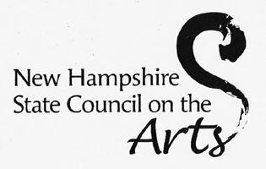
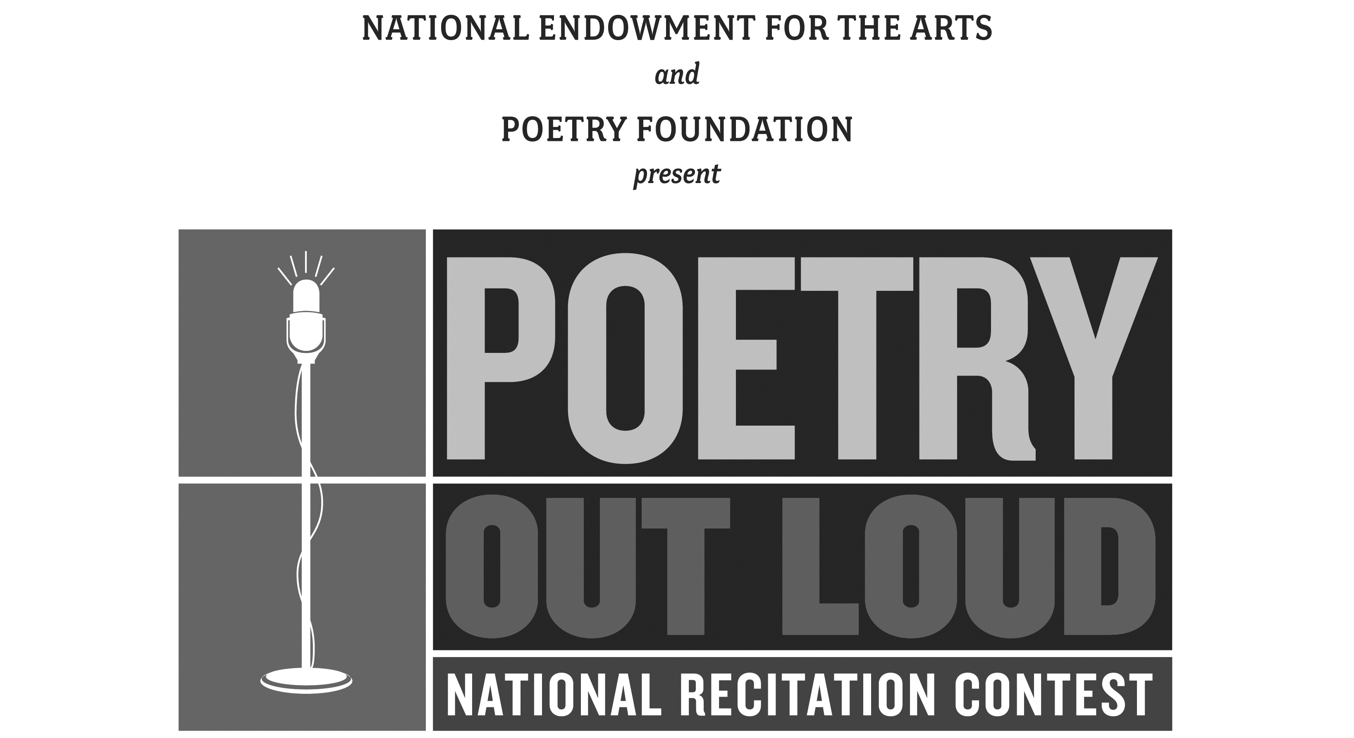
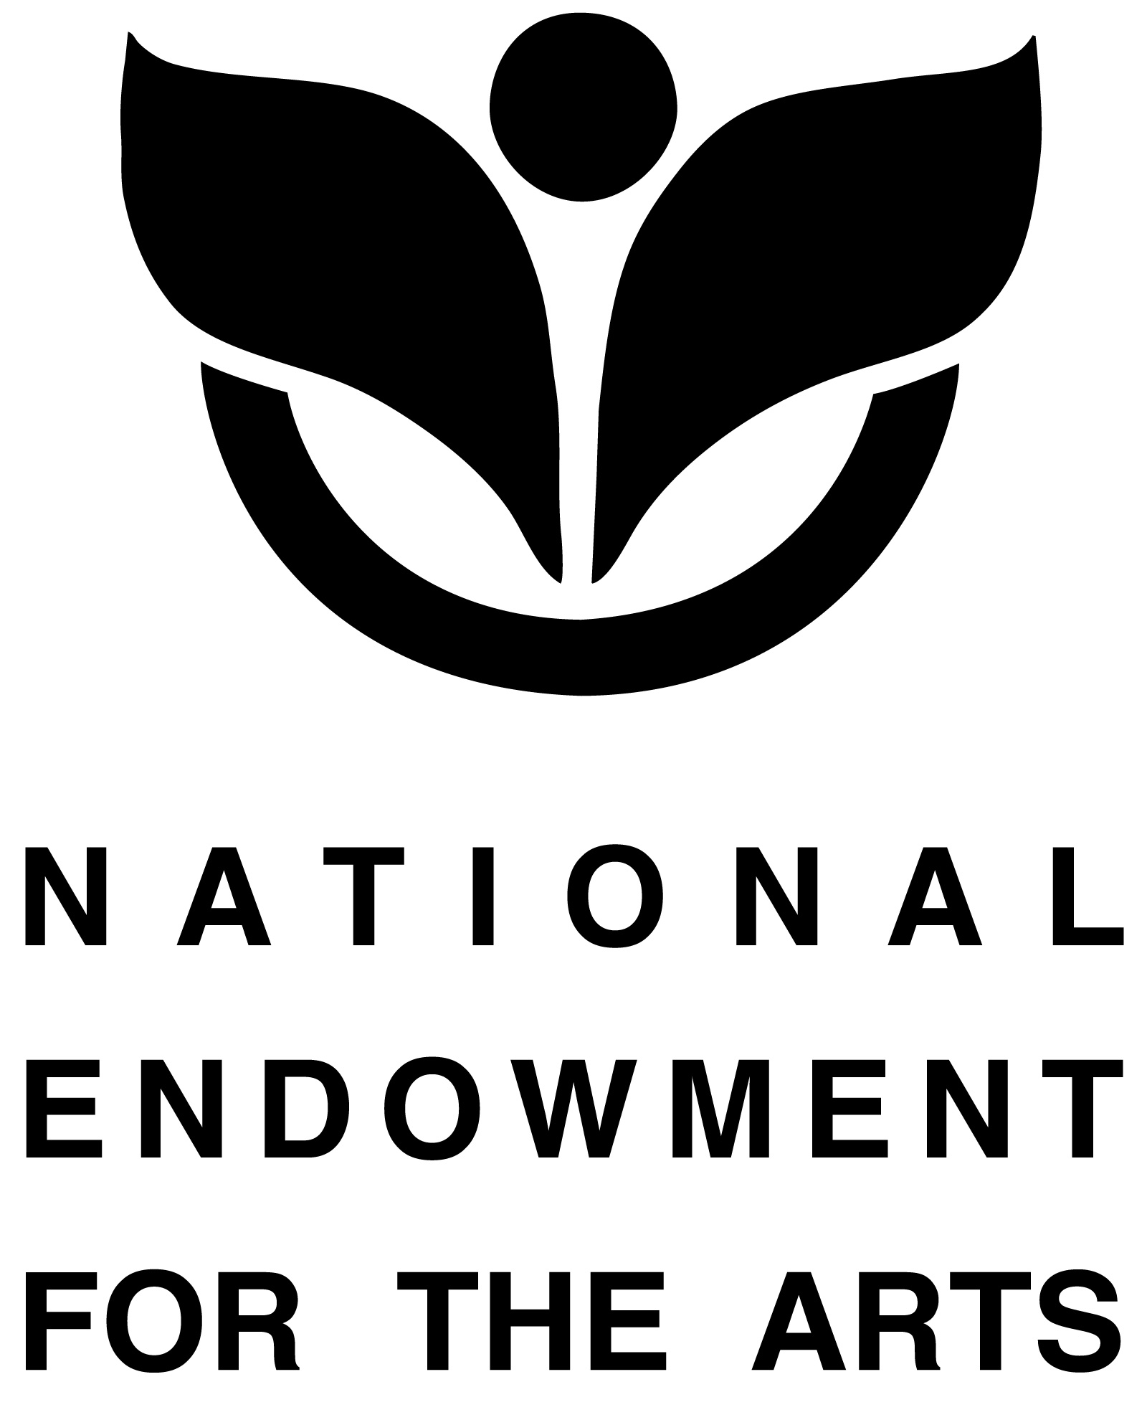

NH Poetry Out Loud 2014-2015
Media Release Form for Students

Please sign, scan, and return via email to Catherine O’Brian at Catherine.R.Obrian@dcr.nh.gov.

Date:

I/we __________________________________________________________________

Grant permission for our child: _____________________________________________
(Please print name clearly!)

Age_____________School________________________________________________

To participate in any and all activities associated with the New Hampshire State Poetry Out Loud Project, and to be photographed and recorded as part of the New Hampshire State Poetry Out Loud Events. Such photos may be used for publicity and archival purposes in the NH Poetry Out Loud Project and on the NH Poetry Out Loud website and social media platforms.

Print parent/guardian's name: ______________________________________________

Signed: _______________________________________________________________
Signature of parent or guardian

