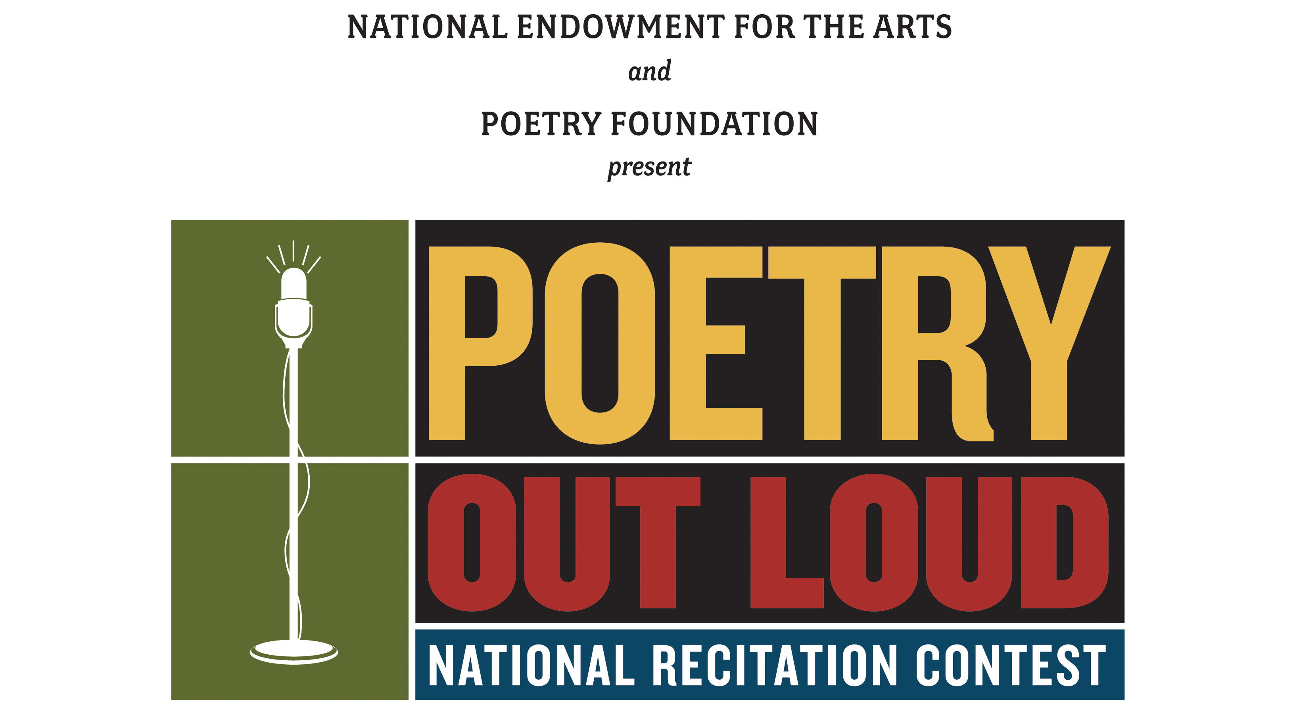


Sample Media Advisory for official New Hampshire Poetry Out Loud high school competitions
For teachers and schools participating in the official Poetry Out Loud contest, use this as a template for a media advisory. We urge you to send your media advisory to local print and TV stations 6-10 days before your high school contest.

[USE YOUR HIGH SCHOOL LETTERHEAD OR YOUR HIGH SCHOOL LOGO HERE]

For Immediate Release Contact: [NAME]

[DATE] [PHONE NUMBER]

MEDIA ADVISORY
[HIGH SCHOOL & TOWN] ANNOUNCES POETRY OUT LOUD CONTEST
WHAT: [HIGH SCHOOL] announces a school contest for the Poetry Out Loud: National Recitation Contest. The competition, presented in partnership with the New Hampshire State Council on the Arts, the National Endowment for the Arts, the Poetry Foundation, the NH Writers Project and many other NH sponsors and partners, is part of a national program that encourages high school students to learn about great poetry through memorization, performance, and competition. (Note- please include your own local sponsors for awards; judges; and # years your high school has been in POL)

On [DATE], more than [NUMBER] students from [HIGH SCHOOL] will participate in the Poetry Out Loud school contest at [LOCATION]. The winner of this competition will advance to the New Hampshire Semi-Finals. The 2012 NH Poetry Out Loud Statewide Final Champion Competition is scheduled to take place March 26, 7 pm at the State House, Representatives Hall in Concord. Doors open at 6:30 pm. All Semi-Finals and the Final Championship competitions are free and open to the public.

The NH champion will advance to the Poetry Out Loud National Finals scheduled to take place on May 13-15, 2012, in Washington, DC, at the Harman Center for the Arts. To learn more go to: www.nh.gov/nharts or www.poetryoutloud.org

WHO: Featured speakers and participants will be:
[HIGH SCHOOL OFFICIALS]
THE MASTER OF CEREMONIES]
[NAMES AND TITLES OF GUEST JUDGES]
WHEN: [DATE, TIME, SNOWDATE?]
WHERE: [LOCATION]
OTHER: Attendance at [EVENT/LOCATION] is free and open to the
public, although seating is limited. For further information, call
[CONTACT] at [NUMBER].
CONTACT: [SPECIFY MEDIA RSVP CONTACT AND DEADLINE FOR MEDIA
RSVPS IF APPLICABLE] # # #

