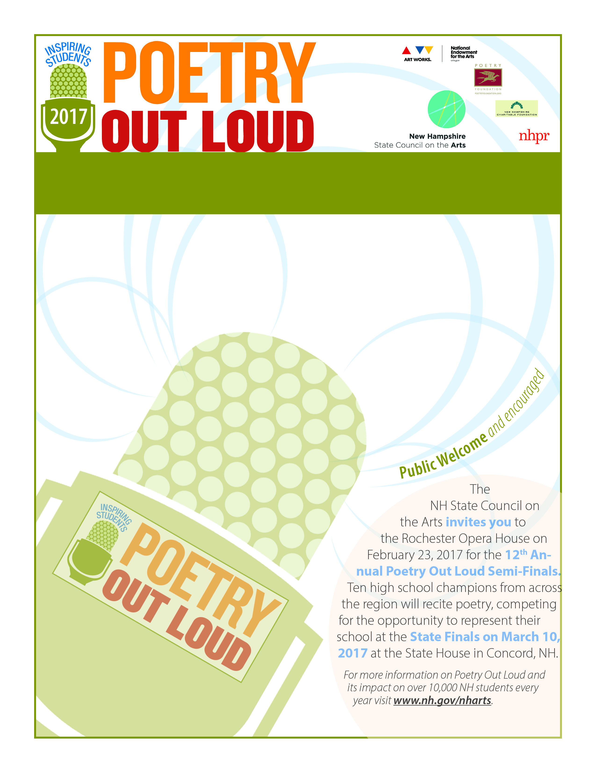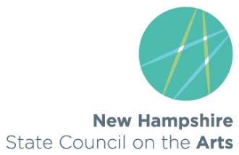

For more information please contact   
[julianne.gadoury@dcr.nh.gov](mailto:julianne.gadoury@dcr.nh.gov)   
**www.poetryoutloud.org**.

**NH POL Champion will receive:**

· A $200 cash prize and an

all-expense-paid trip to Washington, DC

· A $500 cash stipend for their school to purchase poetry materials

· An opportunity to compete at the 2017 National Finals for the title of National Champion and a $20,000 prize

**About The Competition**

The National Endowment for the Arts and the Poetry Foundation have partnered with the New Hampshire State Council on the Arts to support **2017 Poetry Out Loud,** a **FREE** high school program which encourages the nation's youth to learn about great poetry through memorization and recitation. POL helps high school students master public speaking skills, build self-confidence, learn about their literary heritage, and compete for more than $100,000 in awards.

**School Name , Competition Location and Date**

[insert state art agency logo above]

For more information or to register your school, please contact [POL COORDINATOR] at [EMAIL] or [PHONE] or visit **www.poetryoutloud.org**.