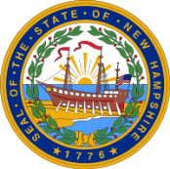
New Hampshire Office of Highway Safety
Final Report- October 1, 2018 – September 30, 2019
Overtime Enforcement Projects

Enforcement Patrol Type (Check one box only)
- STEP | - Distracted Driving
- Operation Safe Commute  - Join The NH Clique | - Pedestrian/ Bicycle
- DWI
- Sobriety Checkpoints / Saturation Patrols

Agency Name ___________________________________________________________________

Project Director _______________________ | Project Number ______________________

Date of First Patrol ____________________ | Date of Last Patrol ____________________

List each project goal submitted in your grant application and provide information on the status of each goal through contract end date, September 30, 2019. Include if you met the goal or did not meet the goal.

If you did not meet a goal, list the goal and provide an explanation including what you could do differently if you are receiving the same grant in fiscal year 20 (October 1, 2019 – September 30, 2020).

Please provide a summary of activities/accomplishments/concerns you want us to know about for this grant year.
HS-7b-Final Report 9/18

