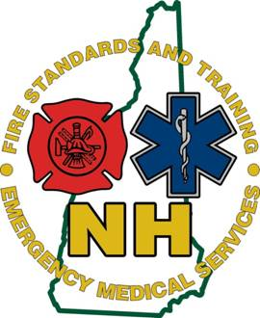

**2015**

**New Hampshire**

**Bureau of**

**Emergency Medical Services**

**EMS in the Warm Zone**

**Active Shooter Best Practice Guide**

**Version 1.0 02/05/2015**

EMS in the Warm Zone

Active shooter events can happen in any community and are increasing in frequency. Since Columbine, CO in 1999 there has been over 100 incidents and according to FEMA 250 people killed between 2000 and 2012, with a drastic rise since 2008[1]. These events will impact all emergency response agencies, regardless of size. Traditionally EMS has been taught to wait for the police to declare the scene safe, but increasingly the casualty outcomes indicate that a change in thinking, training and operations is needed. A National think tank after the Sandy Hook, CT shooting noted that, ‘maximizing survival requires an updated and integrated system that can achieve multiple objectives simultaneously[2].” The Department of Homeland Security also indicates that, ‘in order to maximize lives saved, there is a need to get life-saving medical attention to victims quickly. In previous active shooter incidents, the focus has been exclusively on law enforcement neutralizing the threat[3].”

Given these observations it is imperative that local Fire, EMS, and Law Enforcement use and jointly train on unified command, common terminology, communications, common tactics, and a concept of operations to effectively achieve positive outcomes seamlessly and simultaneously. While no two incidents are identical, there are commonalities that can be maximized and built upon to improve the outcome. The response must also be employed in a form compatible with the resources in any given community.

This document will discuss EMS and fire personnel taking a more active role in Warm Zone operations using the Rescue Task Force (RTF) concept and our integration into a truly unified response with law enforcement. A Rescue Task Force is used to describe a team(s) deployed to provide point-of-wound care to victims while there remains an active threat. The objective of the team is to treat, stabilize, and rapidly remove civilian casualties while wearing ballistic protection and under the protection of Law Enforcement[4]. The RTF shall operate in a Warm Zone or an area of indirect threat that can be considered clear but not secure (i.e. Law Enforcement has either cleared or isolated the threat to a level of minimal or mitigated risk)[5]. While there is a place for tactical EMS, this document and the best practices described will not include this concept.

|  |  |
| --- | --- |
| SOG #  **DRAFT** | Date: TBD |
| Topic: EMS in the Warm Zone | Effective: |
| Subject:  Active Shooter or other violent incident response | Revision Date: |
| Authorizing Signature: |  |

1. Preface

New Hampshire is a mainly rural state of approximately 9,000 square miles with a population just over 1.3 million people in 221 towns and 13 cities. Our communities are served by a combination of first responder agencies (Law Enforcement, Fire, and Emergency Medical Service).

Active shooter and other events that create significant traumatic injuries through violence pose special challenges to our first responders. These will evolve rapidly and without the benefit of sufficient resources. The first responder system bears a responsibility to its providers and the general public to ensure appropriate preparation and that the usual and customary standards of Emergency Medical Service (EMS) care during an incident are maintained and provided to the best extent possible.

Saving lives depends on the rapid but safe and coordinated response from Law Enforcement (LE), Fire and EMS.

1. Purpose

The purpose of this document is to establish policies and procedures for the dispatch and operations of a Rescue Task Force (RTF) in an active shooter or violent incident producing injuries.

1. Definitions
   1. **Active Shooter**: An individual or individuals actively engaged in killing or attempting to kill people in a confined and populated area; in most cases, active shooters use firearms(s) and there is no pattern or method to their selection of victims.
   2. Ballistic Protective Equipment: Ballistic protective gear, including body armor, for the head and body; i.e., vests, gloves, knee pads, helmets, and shields.
   3. **Casualty Collection Point (CCP)**: A location that is used for the assembly, triage (sorting), medical stabilization, and subsequent evacuation of casualties. It may be an intermediary point before formal triage.
   4. **Cleared**: An area has been searched and does not pose a threat – no perpetrator present.
   5. Cold Zone:
      1. Area where no significant danger or threat can be reasonably anticipated.
      2. Area where triage and treatment of patients would occur, additional resources would be staged, and command functions carried out.
   6. **Concealment**: A structure that hides a person’s exact location but can be penetrated by ballistic weapons (e.g. a sheetrock wall).
   7. **Contact Team**: The first responding officers/security personnel who go directly to the ongoing threat, make contact as soon as possible, and neutralize the threat, in order to minimize injuries and lives lost.
   8. **Cover**: An area generally impenetrable to ballistic weapons, such as concrete wall. Something that prevents a responder from being observed by the perpetrator AND provides direct protection from the hazard/threat.
   9. Hot Zone:
      1. Area wherein a direct and immediate life threat exists.
      2. Depends upon current circumstances and is subjective.
      3. Area is dynamic and may change frequently depending upon the situation.
   10. **Incident Command**: A management system designed to enable effective and efficient domestic incident management by integrating a combination of facilities, equipment, personnel, procedures, and communications operating within a common organizational structure, designed to enable effective and efficient domestic incident management.
   11. **Incident Command Post**: The field location where the primary functions of Incident Command are performed.
   12. **Point-of-Wound Care**: The physical location (building or otherwise) where patient care is initiated at or near to where the victim was injured.
   13. **Rescue Task Force (RTF)**: A team or set of teams deployed to provide point of wound-care to victims where there is an on-going ballistic or explosive threat. These teams treat, stabilize, and remove the injured while wearing Ballistic Protective Equipment in a rapid manner under the protection of law enforcement. This response can be deployed to work in, but not limited to, the following:
       1. Active shooter in a school, business, mall, health care facility, conference, special event, etc.
       2. Any other scene that is, or has, the possibility of an on-going ballistic or explosive threat.
   14. **Secured**: An area has been searched and is now under direct Law Enforcement control.
   15. **Soft Target**: A person or thing that is relatively unprotected or vulnerable, especially to attack.
   16. **Tactical Emergency Casualty Care (TECC)**: TECC guidelines are a set of best practice recommendations for casualty management during high threat civilian tactical and rescue operations. Based upon the principles of Tactical Combat Casualty Care (TCCC), TECC guidelines account for differences in the civilian environment, resources allocation, patient population, and scope of practice. The applications of the TECC guidelines for civilian Fire/EMS medical operations are far reaching, beyond just the traditional application in tactical and Law Enforcement operations. The medical response to almost any civilian scenario involving high risk to responders, austere environments, or atypical hazards will benefit from the guidelines, including active shooter response, CBRNE (Chemical, Biological, Radiological, Nuclear, and Explosives) and Terrorism related events, mass casualty, wilderness/austere scenarios, technical rescue events, and even traditional trauma response.
   17. **Unified Command**: An Incident Command System application used when more than one agency has incident jurisdiction or when incidents cross political jurisdictions.
   18. Warm Zone:
       1. Area wherein a potential threat exists, but it is not direct or immediate.
       2. Operating within this zone is permissible in order to save a life, as directed by Unified Command (i.e. Rescue Task Force performing rapid extrication of a victim under security of law enforcement).
       3. This could become a much larger area depending upon the situation.
       4. Warm Zone may by dynamic and become a Hot Zone very rapidly.
2. Preplanning Considerations
   1. Fire/EMS, law enforcement, Public Safety Answering Points (PSAPS) and other public safety partners should work in a coordinated effort to develop standard operating guidelines for Unified Command, common terminology, communications, common tactics, and a concept for operations.
   2. All public safety partners should work cooperatively to identify target hazards and key components of each, such as main access, control rooms, master keys, isolation corridors, maps, and internal communication systems.
   3. All public safety partners should work cooperatively to assess “soft targets”.
   4. Determine multiple locations for potential Incident Command Posts (ICP). All public safety partners should consider situations where responders could converge on the scene and freelance, and to develop strategies to prevent freelancing.
   5. Once preplanning has been completed all public safety partners should work cooperatively to create a pilot policy and training program so as to determine implementation challenges. This pilot program and plan should be delivered through joint training and exercise with cooperating agencies.
   6. Coordination of training agencies:
      1. In order for training to be most effective it should be implemented as a system with all responders collaboratively participating. This practice promotes interoperability well before the event so that any inconsistencies and questions can be addressed.
      2. All training should begin with a plan and end goal in mind. It should start small and build on previous training and education. Communities should conduct joint training and education between local first responders and any other agency that may be expected to respond or participate in case of emergency.
      3. Once foundation training has occurred it should be exercised through Homeland Security Exercise and Evaluation Program (HSEEP) compliant table tops, drills, and full scale exercises. At each stage there should be a feedback mechanism to gather information on activities and challenges to improve the plan and future training.
      4. Training topics should include the following:
         1. Incident Command and Unified Command applied to high threat/active violent situations
         2. Weapons awareness for fire and EMS personnel
         3. Medical scope of RTF
         4. Tactical Emergency Casualty Care (TECC) concepts, including pediatric considerations
         5. Coordination of resources
         6. Equipment specific to the operation
         7. Communications, including importance of radio discipline
         8. Clear expectations of roles for LE, Fire, and EMS
         9. Team role composition and personal traits of members necessary to operate in this specific environment
         10. Dynamic nature of evolving situation and ability to change instantly from warm to hot zone, and expected actions of RTF including the changing availability of resources
         11. Mutual aid locations and integrated training
         12. Shelter-in-place concepts
         13. Casualty Collection Point(s) (CCP)
3. Equipment

It is important to have consistent equipment across all teams not only for medical care but rapid identification of medical personnel. The focus should be on early hemorrhage control and rapid extrication[6]. Consider go-bags or medical vests with the ability to treat at least eight victims with extra equipment bags to treat an additional sixteen victims.

* 1. Equipment to consider (see Figure 3):
     1. Tourniquets (adult and pediatric)
     2. Pressure dressings
     3. Hemostatic agents
     4. Occlusive chest seals
     5. Adjunct airways (Adult and Pediatric)
     6. Chest decompression needles (paramedics)
     7. Personal safety / protective equipment shall be available for RTF teams. All ballistic body armor / protection should be compliant with the current NIJ (National Institute of Justice) Ballistic Resistance Standard, 0101.06, minimum Type IIIa (see Figure 4):
        1. Ballistic vests with clear identification of RTF/EMS
        2. Ballistic helmet
        3. Eye protection
        4. Flashlight
     8. Two-way radio with remote microphone or ear piece/microphone
     9. Lightweight and single person deployable patient moving devices
     10. Packaging for rapid deployment of RTF equipment by team members
     11. Packaging for rapid resupply of RTF team
  2. Go-bag for EMS/Patient care equipment – portable, carried on your person and packaged for efficiency. Each set of equipment should be able to treat at least eight (8) patients with the provision for extra equipment (See Figure 3 for suggested list of equipment).

1. Procedure
   1. Law enforcement will be the lead agency and will establish a Unified Command with Fire/EMS to rapidly deploy RTF teams into established zones.
   2. The RTF composition should consist of a minimum of four (4) personnel[7]: Two (2) EMS and two (2) Law Enforcement.
      1. There should be a Law Enforcement officer for each EMS provider to deliver security.
      2. RTF/EMS personnel should be certified and licensed. EMS personnel should perform to their Scope of Practice.
   3. Prior to deploying an RTF team, threat zones must be identified:
      1. **Hot Zone** – (also known as the area of direct threat) area where there is known hazard or life threat that is direct and immediate. An example of this would be any uncontrolled area where the active shooter could directly engage an RTF team. RTF teams will not be deployed into a Hot Zone.
      2. **Warm Zone** - (also known as the area of indirect threat) areas that law enforcement has either cleared or isolated the threat where there is minimal or mitigated risk. This area can be considered clear but not secure. This is where the RTF will deploy, with security, to treat victims.
      3. **Cold Zone** - areas where there is little or no threat, either by geography or distance in relation to threat, or after area has been secured by law enforcement. This is an area where Fire/EMS will stage to triage, treat, and transport victims once removed from the warm zone.
   4. Command and Control:
      1. Coordination should include the following:
         1. Shared common terminology and communication across fire/EMS/law enforcement.
         2. Span of control.
         3. Jointly developed protocols for response.
         4. Planning for and practicing rapid treatment and evacuation of patients[8].
      2. RTF can be deployed for the following reasons:
         1. Casualty treatment.
         2. Casualty removal from warm to the CCP or to the cold zone.
         3. Movement of supplies from cold to warm zone.
   5. Response:
      1. Initial dispatch

When the local emergency communications/dispatch receives a call for an active shooter or violent incident with injuries the original dispatch will be for (enter local dispatch nomenclature) call type. This will generate the following response:

* + - 1. Law Enforcement patrol units (define a minimum for your community).
      2. Fire/EMS units (define a minimum for your community).
      3. Units dispatched should enable at least one RTF with necessary equipment to be placed in operation.
    1. If Fire/EMS responders encounter a threat (i.e. active shooter(s)) in the staging area prior to Law Enforcement arrival, they shall immediately withdraw. When withdrawal is not possible, seek cover and request an expedited law enforcement response. Communicate unit identifier and location to Law Enforcement. When possible, provide the following information:
       1. Number, location(s), and description of shooter(s).
       2. Types of weapons in use (e.g., semiautomatic rifles, hand guns, explosives, etc).
       3. Number and location(s) of victims and hostages, if known.
       4. Communication method used by the shooters, if apparent (cell phones, radios).
       5. Contact Teams (CT’s) will be established to address the threat. The CT’s goal is to neutralize the threat.
  1. The first arriving units should:
     1. Determine if they are responding into a static or ongoing situation and relay this information to dispatch.
     2. Identify if predetermined staging area is safe. If not safe, consider an area out of the line of sight of incident, in line of approach to location.
     3. Law Enforcement will establish 1-2 Contact Teams of 1-4 officers to address the threat.
     4. When appropriate personnel arrive on scene, Law Enforcement and Fire/EMS personnel will assemble into Rescue Task Forces of 2 EMS providers and 2-4 law enforcement and prepare for deployment. (Figure 1).
  2. If possible, determine a Casualty Collection Point (CCP) prior to deploying. Depending on the size of the incident and location, injured victims may need to be placed in a CCP before transition to the cold zone. This will be predetermined by initial units, protected by Law Enforcement, and relayed to the RTF teams through Unified Command. As this area may be secure, it may be considered a cold zone and may be staffed with non-RTF Fire/EMS personnel.
  3. Rescue Task Force deployment:
     1. Once Unified Command has identified the need to deploy RTF teams, they will be deployed into the warm zone to begin victim care and evacuation as needed. The goal of initial RTF team is to stabilize as many victims as possible.
     2. Command will dispatch RTF teams by numbers, i.e., RTF Team 1. RTF Teams are not to deploy unless they have two personnel from Law Enforcement as security. Do not self-deploy into the warm zone.
     3. Command shall:
        1. Establish RTF resupply near point of entry.
        2. Establish an external Casualty Collection Point (CCP).
        3. Designate area(s) in the cold zone to receive patients for treatment and transportation, as appropriate.
     4. The least number of personnel and teams should be deployed into the warm zone to achieve the goals.
     5. All RTF teams that make entry shall notify the Incident Commander of their location and any victims encountered. Constant communication between the IC and RTFs is essential for effective resource coordination and allocation.
     6. When teams make entry, they will treat the injured using Tactical Emergency Casualty Care (TECC) guidelines.
     7. Should the RTF encounter a threat/suspect the medical personnel shall:
        1. Evacuate if safe to do so.
        2. Shelter in a place that provides protection to medical personnel, preferable with an exterior door or means of escape.
     8. When the RTF is operating in the Warm Zone, all patients encountered by the RTF teams will be treated as they are accessed. Any patient who can ambulate without assistance will be directed by the team to self-evacuate down the cleared corridor under Law Enforcement direction. Any patient who is dead will be visibly marked to allow for easy identification and to avoid repeated evaluations by additional RTF teams.
     9. The first RTF teams in operation will enter the area and treat as many patients as possible.
     10. Additional RTF teams that enter the area should be primarily tasked with extrication of the victims already treated by the initial team(s). However, if needed, additional RTF teams may be sent into areas unreached by the initial teams or to other areas with accessible victims. (Figure 2)
  4. Additional tasks for local resources:

Communities should predetermine tasks for arriving units and assign those in each local plan. The following tasks should be assigned as local resources arrive:

* + - 1. Assume or establish Command for first responder units.
      2. Meet with law enforcement to establish Unified Command.
      3. Establish personnel accountability, especially if members have already entered the warm zone.
      4. Work with law enforcement to identify the RTF working zones.
      5. Consider adding an additional EMS Taskforce or MCI Alarm for patient treatment and transport.
      6. Consider primary staging to a larger or safer area if needed.
      7. Create RTF teams from deployed units.
      8. Equip RTF Teams with proper protective gear and equipment.
      9. Designate Casualty Collection Points (CCP).
      10. Once Unified Command has declared the working zones, RTF teams must be informed of their working limits.
      11. Use command boards to label and keep track of RTF teams.
      12. EMS staging in the Cold Zone and a Treatment Dispatch Manager need to be considered for larger numbers of patients.
      13. Establish a resupply for extended RTF operations.
      14. Prepare to establish staging for transport units, treatment, and transportation areas.
      15. Consider mutual aid for coverage of ongoing emergency needs of community.
  1. Fire Suppression Considerations:

Consider assigning personnel to control fire suppression and protection systems if safe to do so.

* 1. Communications:

Clear/plain language communication is vital. The following elements should be determined in preplanning and should be practiced and adhered to:

* + 1. Use of plain language
    2. Common definitions
    3. Command and control
    4. Strict radio etiquette
    5. Radio frequencies assigned for interoperability
    6. Radio frequency assigned to the RTF
    7. Use of ear microphone, lapel microphone, and designated communicators

1. Patient Care
   1. EMS personnel should treat the injured as an MCI using Tactical Emergency Casualty Care (TECC) concepts and guidelines. Rapid identification, treatment and evacuation are paramount. Ambulatory victims should self-evacuate and fatalities should be clearly marked.
   2. TECC, “provides a framework to prioritize medical care while accounting for on-going high-risk operations.”[9]
      1. Medical scope should have at its core:
         1. Focus on THREAT acronym:

**T**hreat suppression

**H**emorrhage control

**R**apid **E**xtrication to safety

**A**ssessment by medical providers

**T**ransport to definitive care

1. **TECC Goals:** 
   1. Accomplish the mission with minimal casualties.
   2. Prevent any casualty from sustaining additional injuries.
   3. Keep response team maximally engaged in neutralizing the existing threat (e.g. active shooter, unstable building, confined space HAZMAT, etc.).
   4. Minimize public harm.
2. **TECC Principles:** 
   1. Establish tactical supremacy and defer in depth medical interventions if engaged in ongoing direct threat (e.g. active fire fight, unstable building collapse, dynamic post-explosive scenario, etc.).
   2. Threat mitigation techniques will minimize risk to casualties and the providers. These should include techniques and tools for rapid casualty access and egress.
   3. Triage should be deferred to a later phase of care. Prioritization for extraction is based on resources available and the tactical situation.
   4. Minimal trauma interventions are warranted.
   5. Consider hemorrhage control.
   6. Tourniquet (TQ) application is the primary “medical” intervention to be considered in Direct Threat.
   7. Consider instructing casualty to apply direct pressure to the wound if a tourniquet is not available, or application is not tactically feasible.
   8. Consider quickly placing or directing casualty to be placed in position to protect airway.
3. **TECC Guidelines:** 
   1. Mitigate any threat and move to a safer position (e.g. Return fire, utilize less lethal technology, assume an overwhelming force posture, extraction from immediate structural collapse, etc.).
   2. Direct the casualty to stay engaged in any tactical operation if appropriate.
   3. Direct the casualty to move to a safer position and apply self aid if able.
   4. Casualty Extraction
   5. If a casualty can move to safety, they should be instructed to do so.
   6. If a casualty is *unresponsive*, the scene commander or team leader should weigh the risks and benefits of a rescue attempt in terms of manpower and likelihood of success.
   7. Remote medical assessment techniques should be considered.
   8. If the casualty is *responsive* but cannot move, a tactically feasible rescue plan should be devised.
   9. Recognize that threats are dynamic and may be ongoing, requiring continuous threat assessments.
   10. *Stop life threatening external hemorrhage* if tactically feasible:
       1. Direct casualty to apply effective tourniquet if able.
       2. Apply the tourniquet over the clothing as proximal-- high on the limb-- as possible.
       3. Tighten until cessation of bleeding and move to safety. Consider moving to safety prior to application of the TQ if the situation warrants.
       4. For response personnel, tourniquet should be readily available and accessible with either hand.
       5. Consider instructing casualty to apply direct pressure to the wound if no tourniquet is available or application is not tactically feasible.
   11. Consider quickly placing casualty, or directing the casualty to be placed, in position to protect airway if tactically feasible.

NOTE: Once patients have been moved / relocated to an established treatment area, patient care by EMS providers shall be accomplished utilizing recognized New Hampshire Patient Care Protocols.

**Figure 1**

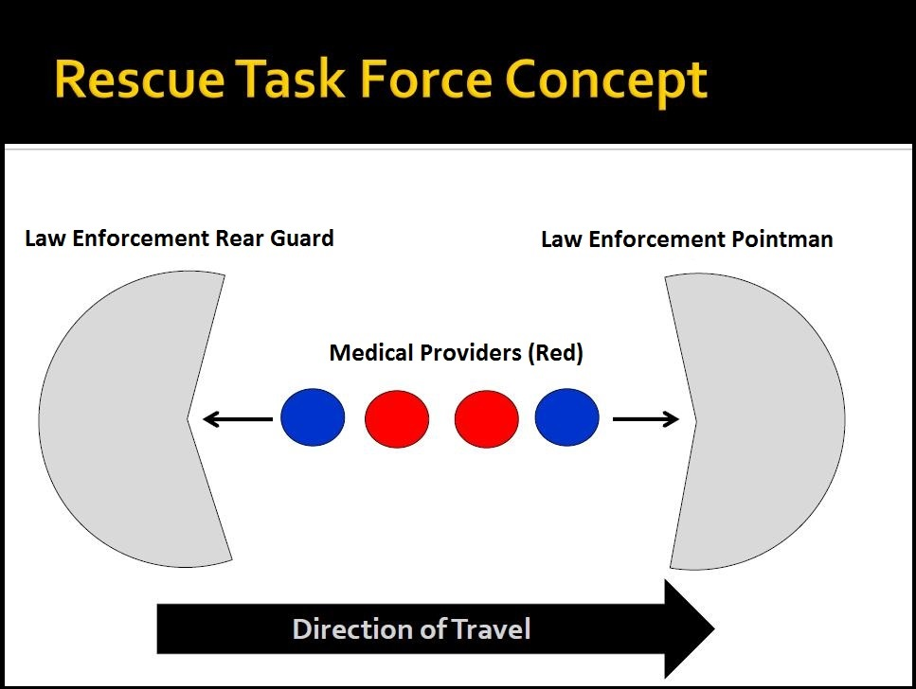

**Figure 2**

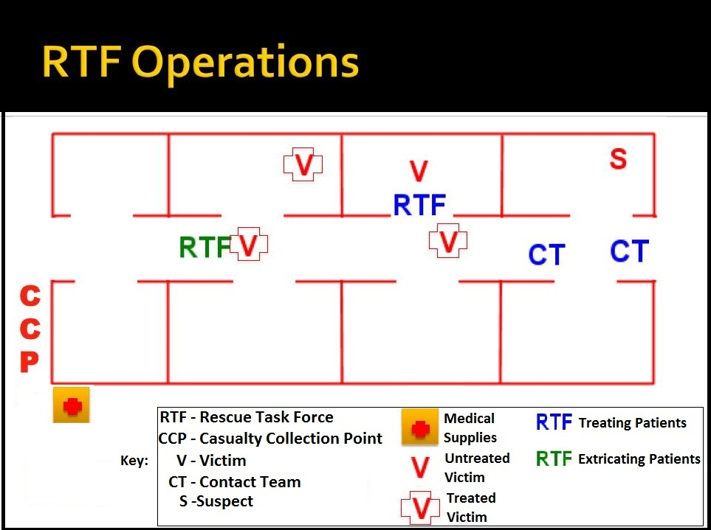

**Figure 3**

*SUGGESTED GO-BAG EMS EQUIPMENT LIST*



|  |  |
| --- | --- |
| **QTY** | **ITEM** |
| **6** | **CAT (or similar) Tourniquets (adult & pedi)** |
| **4** | **Occlusive Dressings / Chest Seals** |
| **2** | **ARS Needles (14ga X 3.25")** |
| **10** | **4X4 Gauze** |
| **4** | **Chito Gauze Bandages** |
| **2** | **6-inch Israeli Bandages** |
| **2** | **4-inch Israeli Bandages** |
| **6** | **6-inch elastic roll** |
| **1** | **roll of tape** |
| **4** | **pairs of gloves** |
| **Various** | **NPAs w/surgilube** |
| **1** | **Trauma Shears** |

**Figure 4**

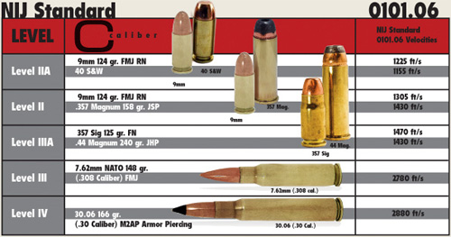

1. FBI Law Enforcement Bulletin January 2014
2. Hartford Consensus April 2, 2013
3. Homeland Security, Office of Health Affairs: Stakeholder Engagement on Improving Survivability in IED and Active Shooter Incidents, May 16, 2014
4. International Association of Firefighters – Position Statement: Active Shooter Events (June 17, 2013)
5. International Association of Fire Chiefs Position Statement – Active Shooter and Mass casualty Terrorist Events (October 10, 2013)
6. Hartford Consensus April 2, 2013
7. International Association of Fire Chiefs Position Statement – Active Shooter and Mass casualty Terrorist Events (October 10, 2013)
8. U.S Fire Administration: Fire/Emergency Medical Services Department Operational Considerations and Guide for Active Shooter and Mass Casualty Incidents (September, 2013)
9. International Association of Fire Chiefs Position Statement – Active Shooter and Mass casualty Terrorist Events (October 10, 2013)