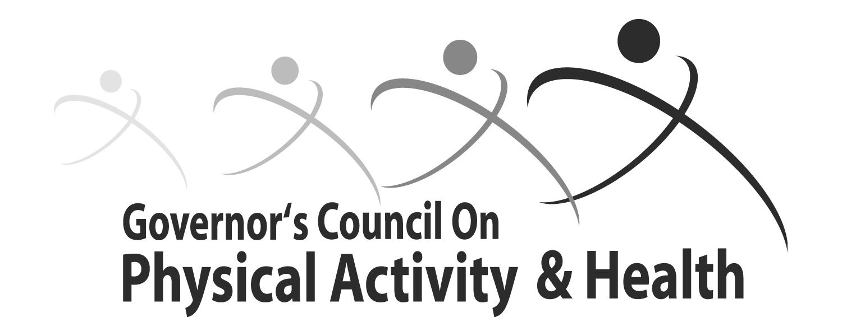

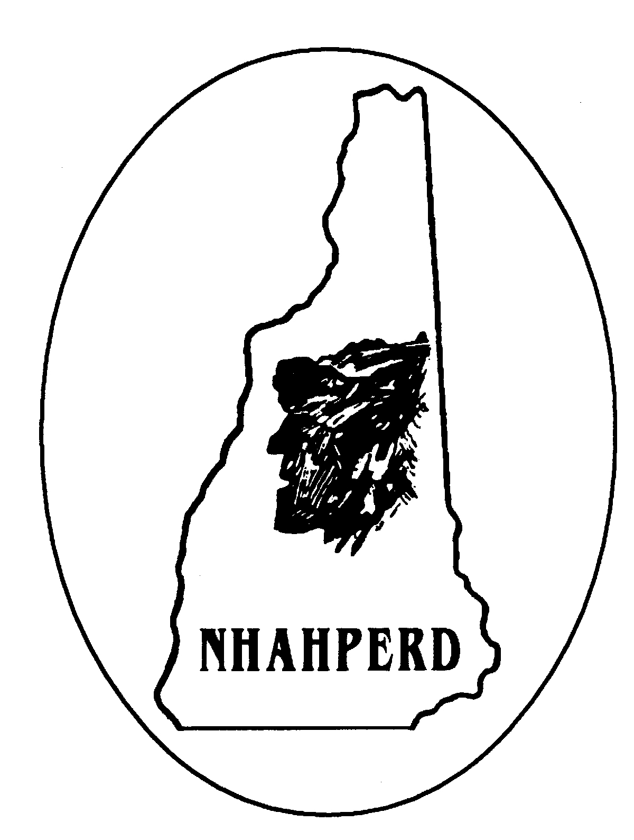
Why you should participate at our Intergenerational Wellness Walk taking place on May 26th… (all schools, businesses, organizations and health & physical activity enthusiasts are encouraged to attend)

By joining together with other NH citizens on May 26, 2010, you'll help the Governor’s Council on Physical Activity & Health in decreasing physical inactivity and increasing health awareness.

- Yes, I will join in on the 5K Walk on Wednesday, May 26, 2010, to raise awareness for the importance of employee physical activity & health.

We will participate in the 5K Walk ONSITE (Concord, NH)

We will participate in the 5K at a SATELLITE location

*Suggested donation $2: All donations go to the Governor’s Council on Physical Activity & Health
Your Name:
Physical Address:
City: |  |  |  |  |  |  |  |  | State: |  |  | Zip:
Mailing Address:
(if different from physical address)
City: |  |  |  |  |  |  |  |  | State: |  |  | Zip:
Phone Number: |  |  |  | ( ) |  |  | E-Mail Address:
Date of Walk (if different than 5/26/2010):
Notes:

*Register and make a donation before May 3, 2010 to be eligible for a T-shirt giveaway: Payments made payable to GCPAH and mailed to: Dianne Rappa, Treasurer, P.O. Box 123, Bath, NH 03740

For more information, please visit our website @ http://www.nh.gov/gcpah/
OR
Email Travis Horne @ (thorne@nhlgc.org)

Thank you for participating at our Intergenerational Wellness 5K Walk!

